**BRM LAB FILE-9**

**Aim: Automation testing using Selenium IDE for testing a web page.**

**Steps:**

1. Add Selenium IDE extension to the chrome.
2. Open the IDE and create a project by clicking on record a new project option.
3. Assign the name of the project (here, BRMLAB9).
4. Add the base URL (here, <https://www.testandquiz.com>).
5. Start the recording.
6. Perform tests and save it.
7. Run the class test.

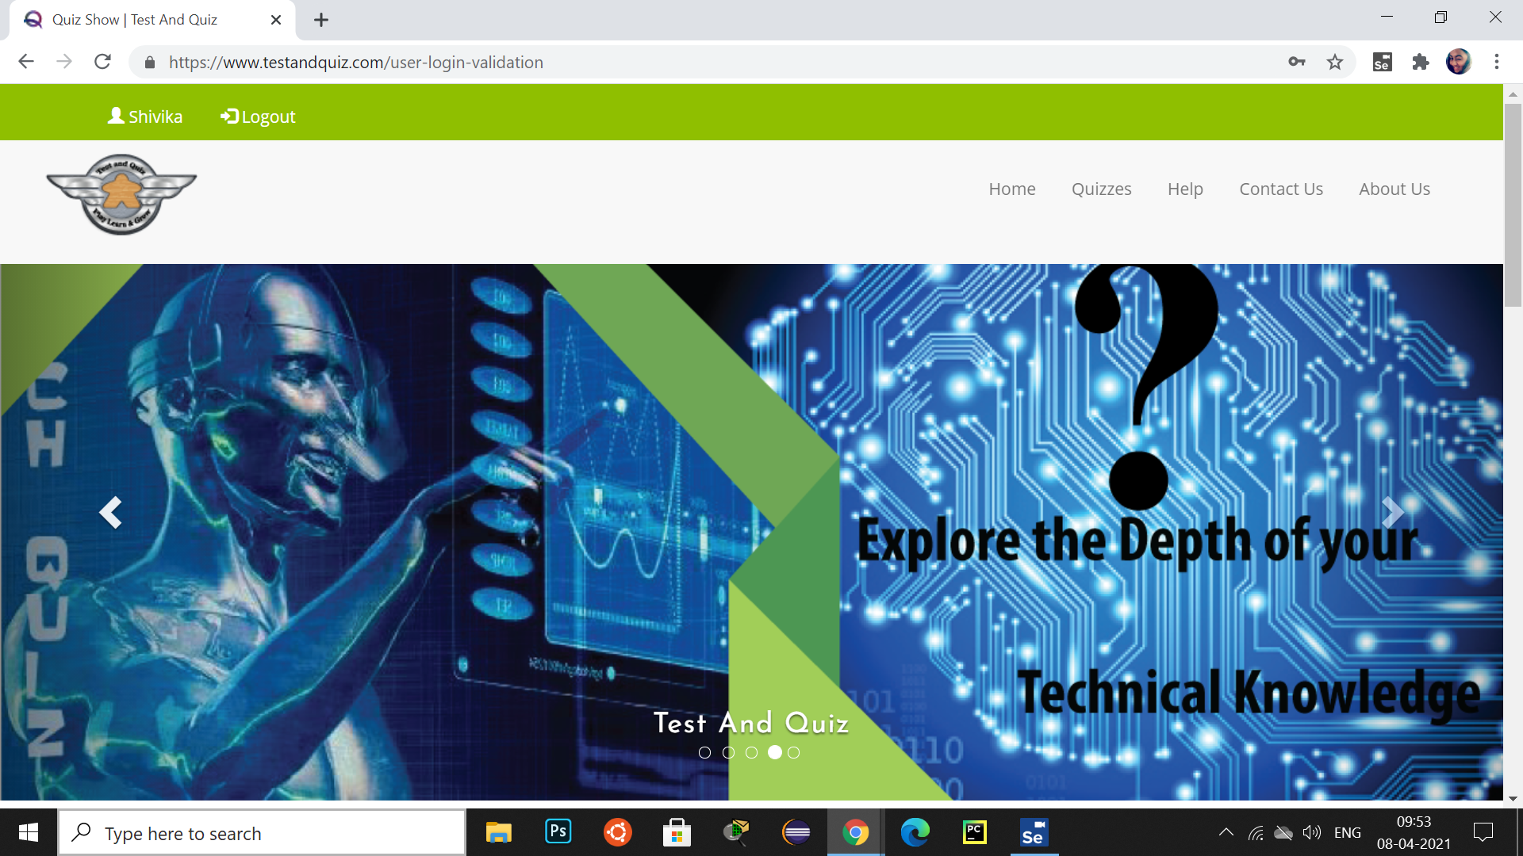

**Output:**

